

Admin pharmaceuticals from the MAR
Giving medications is one of the most common, time-sensitive tasks you do during your shift. Use these tips to make the MAR show the types of details you want to see depending on different stages of the medication administration process:
- Sort medications by name, pharmaceutical class, route, or reverse order date (so you see the newest orders first) by clicking and selecting an option in the Sort by field. Sorting is especially helpful when you're preparing to administer medications. For example, you can prepare all of the PO meds that are due before preparing the IVs.
- To view additional details about a single med, click anywhere in the white space.
- To view details for all medications when you're reviewing the med list, click Show All Details. This is useful when you're preparing to administer several medications at once.
- To have medication details expanded every time you open the MAR, click and select the Expand Medication Details check box.
- Hide administrations and due times by clicking Hide All Admins. Hiding administrations is especially helpful when you want to review the med list for patients with a long list.
- Check interaction information by clicking before administering the medication.
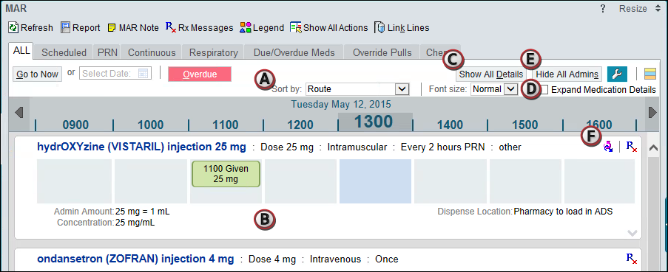

Give a medication
- Scan the patient's wristband. The MAR opens.
- Scan the medication you're administering.
- If the patient has multiple meds due at the same time, scan them all now.
- If the dose has multiple components, such as two Tylenol tablets, scan each component individually. The partial dose is denoted by a icon.
- If the dose has linked medications, scan each component individually.

